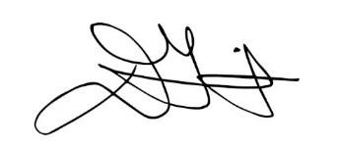

August 14, 2019

Dear Parents or Guardians:

Tulsa Public Schools believes extraordinary teachers are the heart of successful schools, and we work diligently to ensure each teacher is appropriately placed in a supportive environment where they will have the greatest impact on student success. In accordance with the Every Student Succeeds Act (ESSA), we want you to know that every parent of a student in a Title I school has the right to request and receive information regarding the professional qualifications of your student’s classroom teachers.

Information regarding the professional qualifications of your child’s classroom teacher includes the following:

- Has the teacher met state qualification and licensing criteria for the grade level and subject areas taught;
- Is the teacher teaching under emergency or temporary status in which the state qualifications and licensing criteria are waived;
- What is the teacher’s baccalaureate degree major, graduate certification, and field of discipline; and
- Is the student being provided services by paraprofessionals, and if so, their qualifications?

In addition to the above information, you will be notified if your child has been taught for four or more consecutive weeks by a teacher who is not certified in the content area or grade level in which he or she is placed.

Parents and families of students in Title I schools also have a right to know about state or district policies regarding student participation in any assessments mandated by ESSA, including any policy, procedure, or parental right to opt students out of such assessments. If you would like to receive information about this topic, please contact Erin Lester, Director of Assessment, either by phone at (918) 746-6255, or in writing at lesteer@tulsaschools.org.

Tulsa Public Schools is committed to helping your child develop the academic knowledge and critical thinking he or she needs to succeed in school and beyond. If you have questions or concerns, please feel free to contact your school principal. We invite you to check out our newly updated website at www.tulsaschools.org – you
will find lots of great information, including our district family engagement policy, by clicking on the “Parents” icon.

Best,

Deborah A. Gist Superintendent

